# Part V Process modeling（过程模型？？？）

1. Given the accompanying use-case (event/response) matrix in Exhibit 6.1, draw the *Event Decomposition Diagram.* For background information on each use case, see the meeting transcript in Exhibit 3.1 of Milestone 3 and Exhibit 4.1 of Milestone 4.

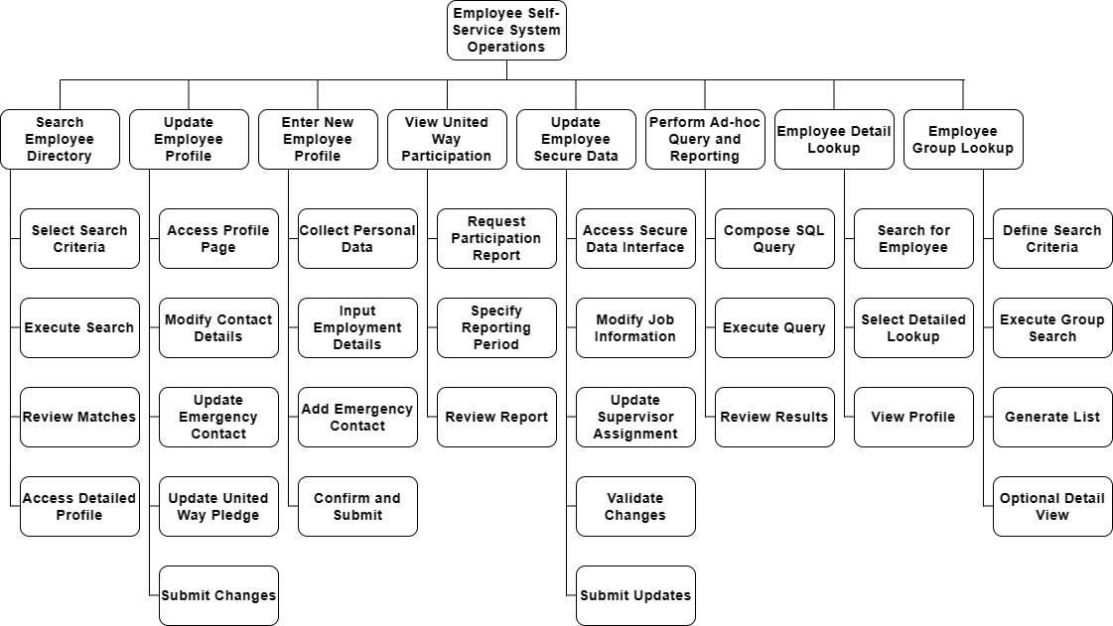

1. Given your decomposition diagram from above and the use-case matrix, draw *Event Diagrams.* Your instructor will tell you which ones to draw. Use your data model from Milestones 3 and 4 as an attribute reference. Also, state any assumptions you make.

Search Employee Directory:

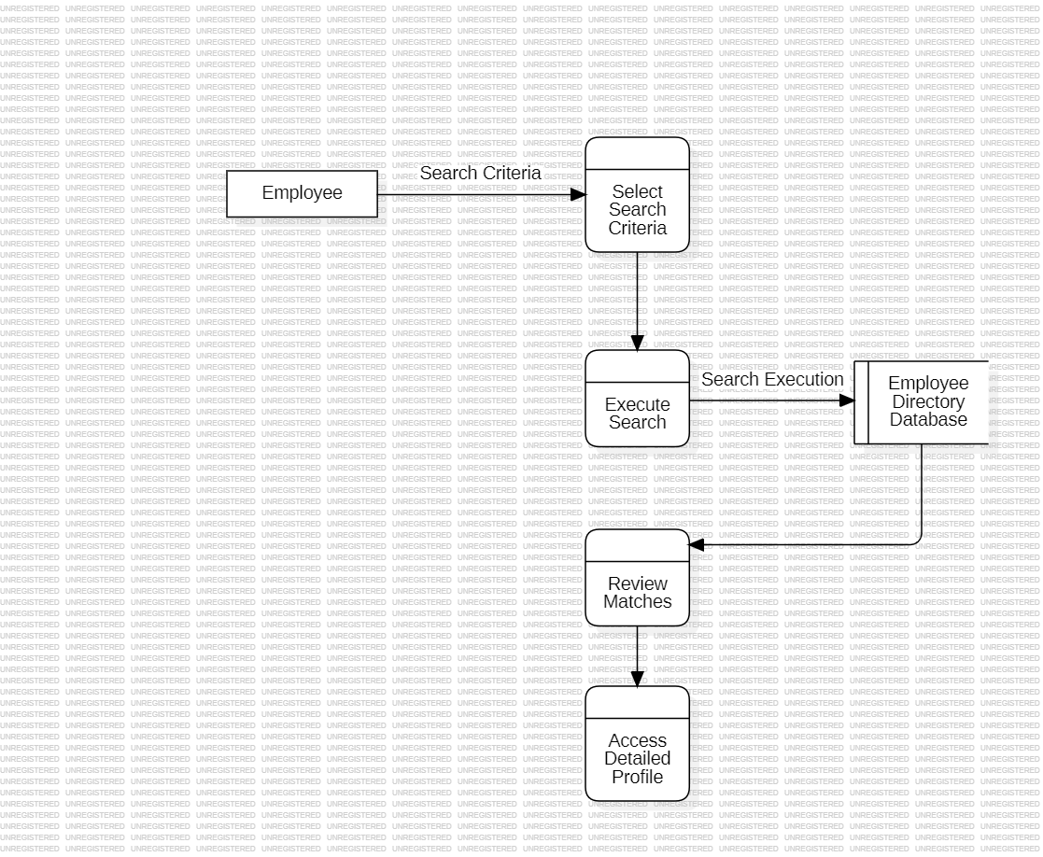

Update Employee Profile:

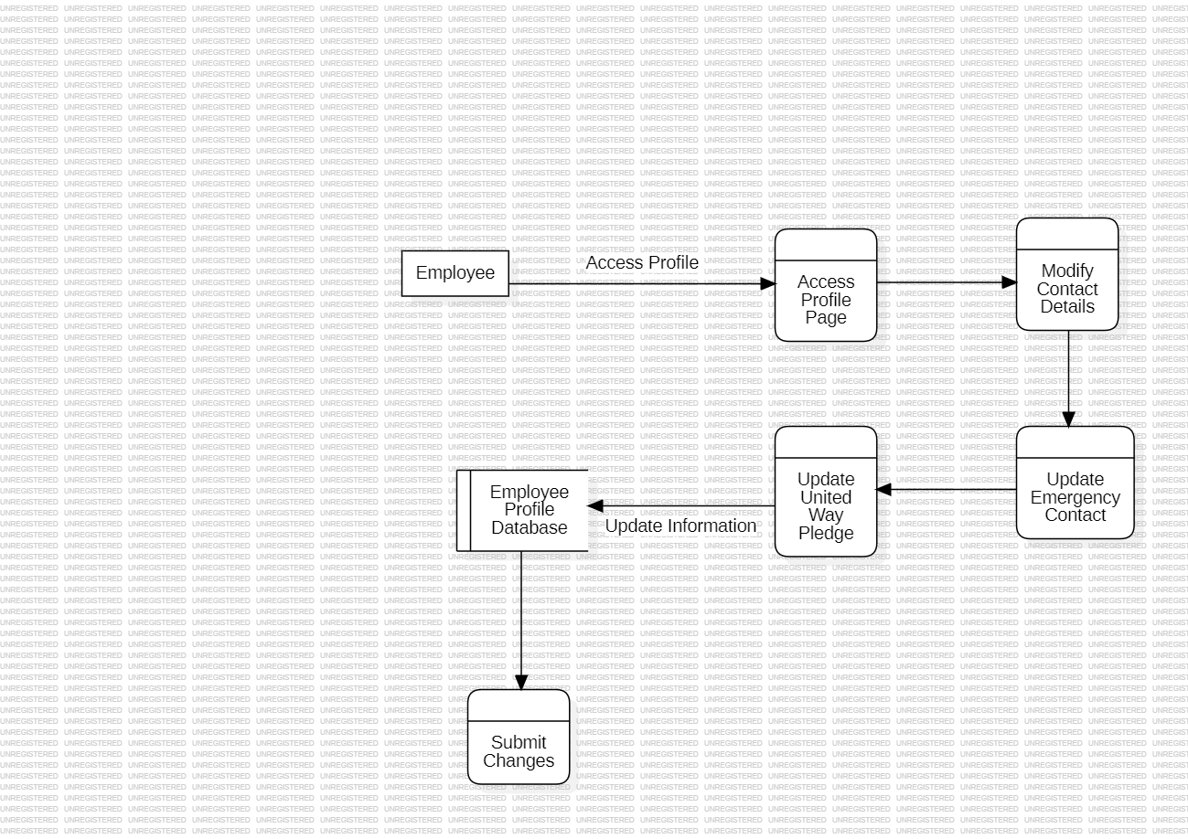

Enter New Employee Profile:

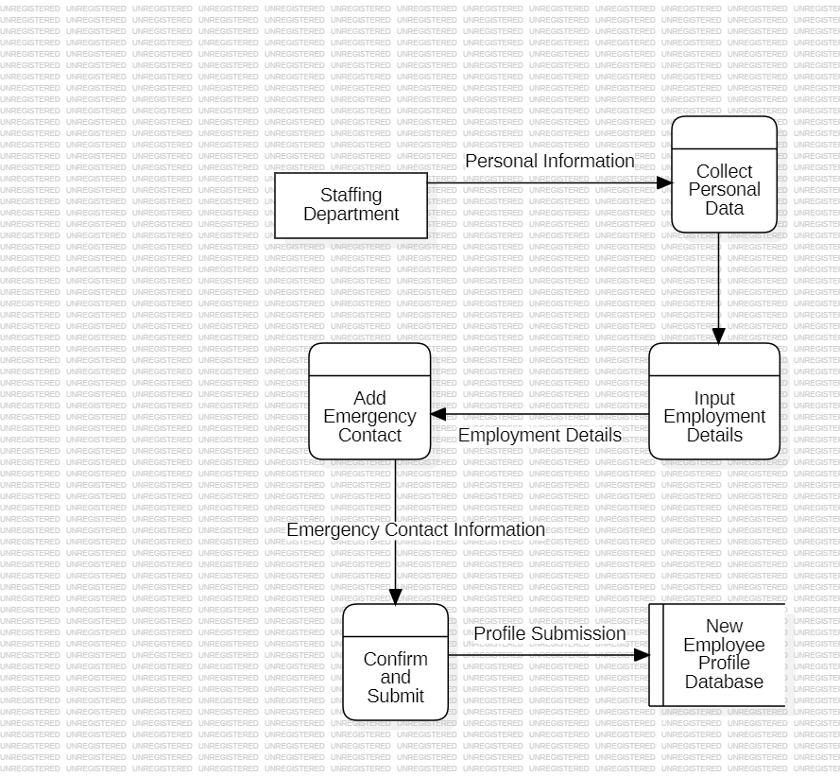

View United Way Participation:

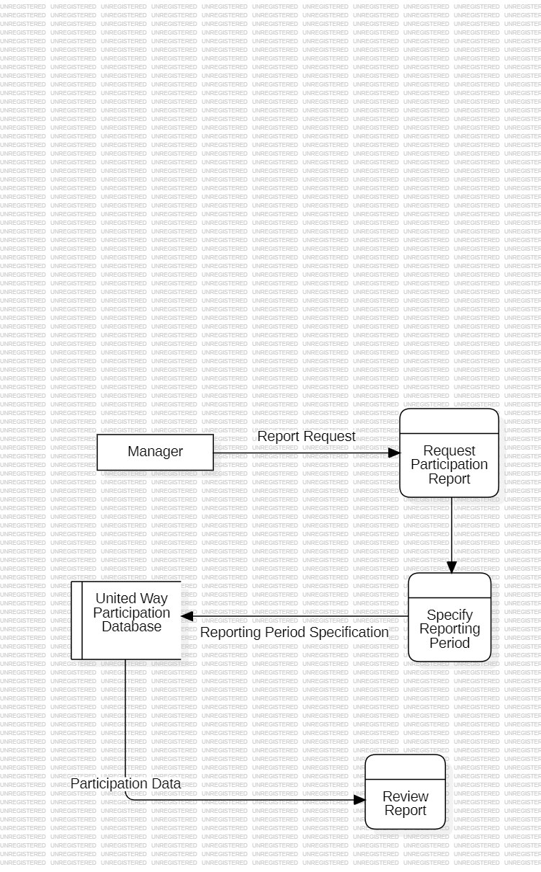

Update Employee Secure Data:

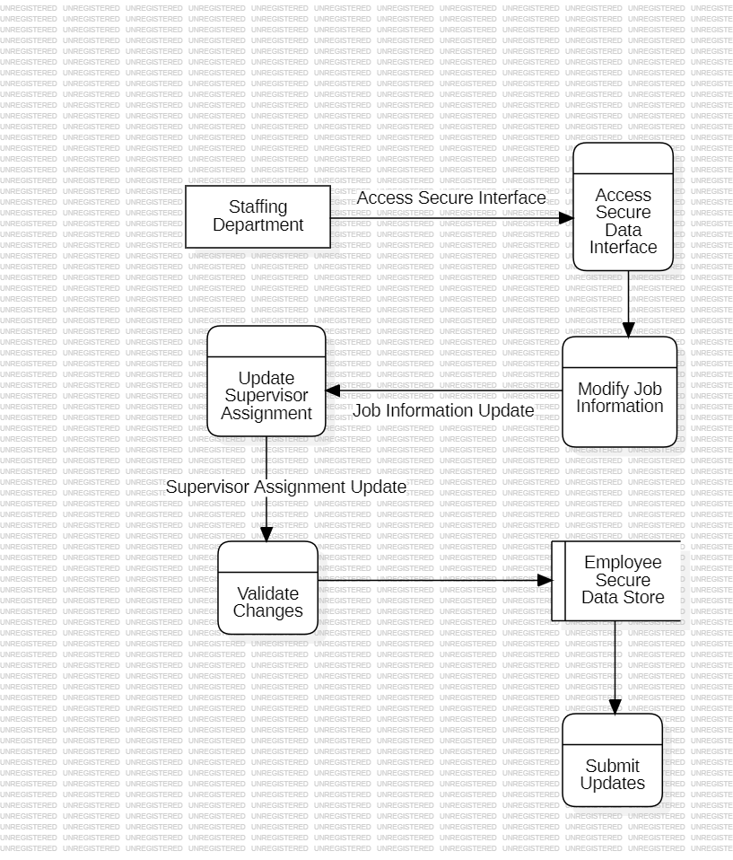

Perform Ad-hoc Query and Reporting:

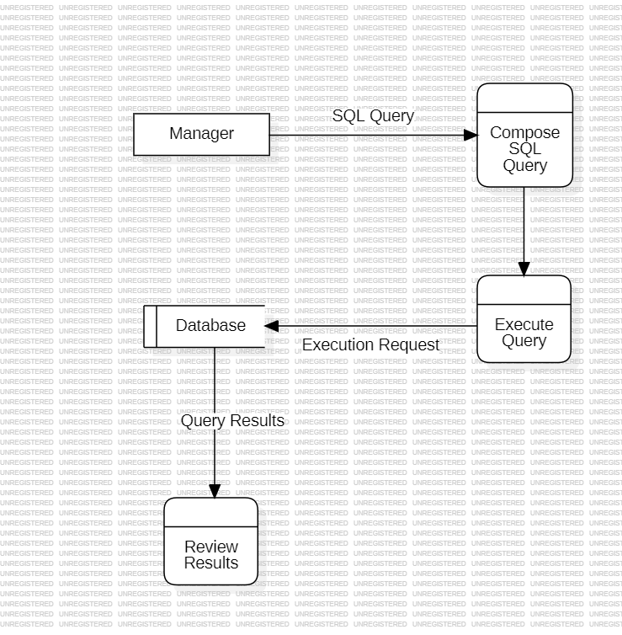

Employee Detail Lookup:

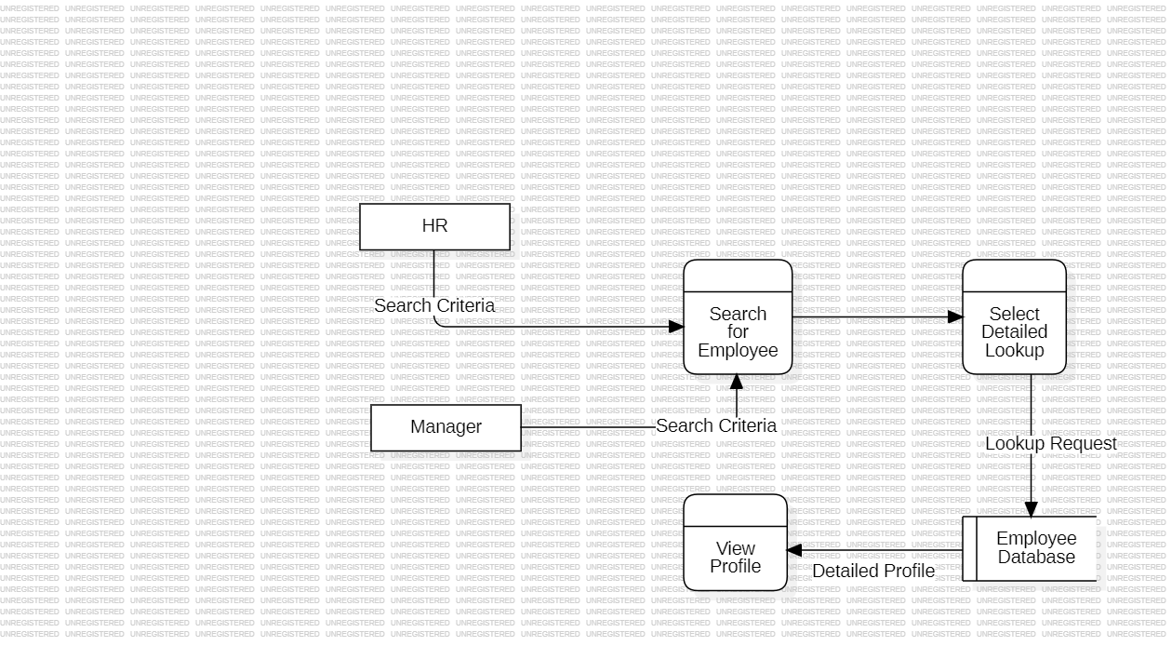

Employee Group Lookup:

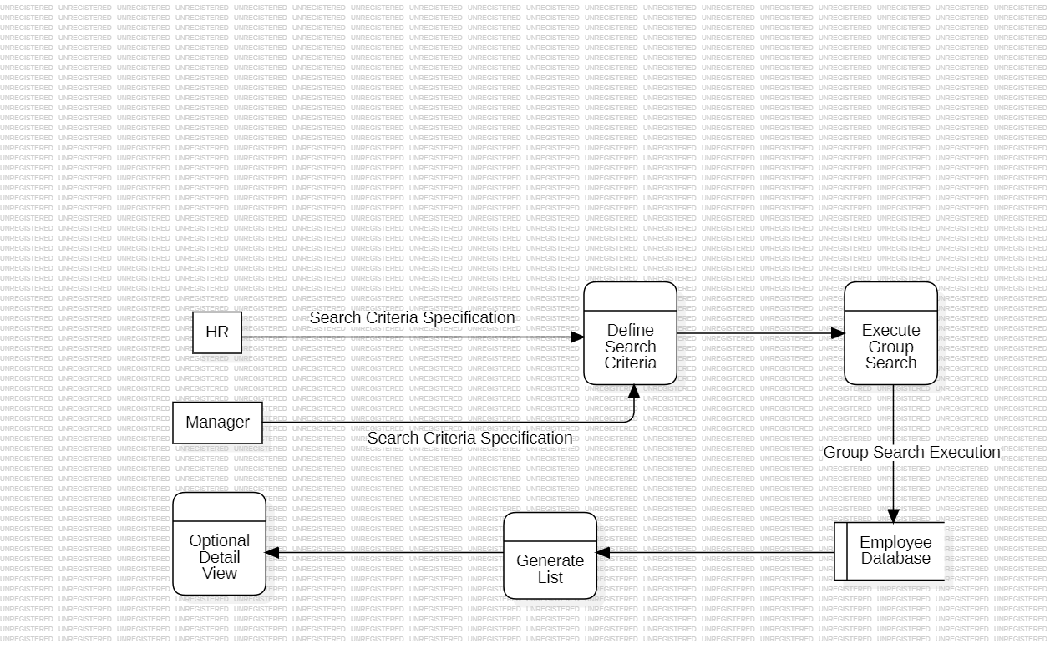

1. Merge your event diagrams from #3 above into a *System Diagram*.

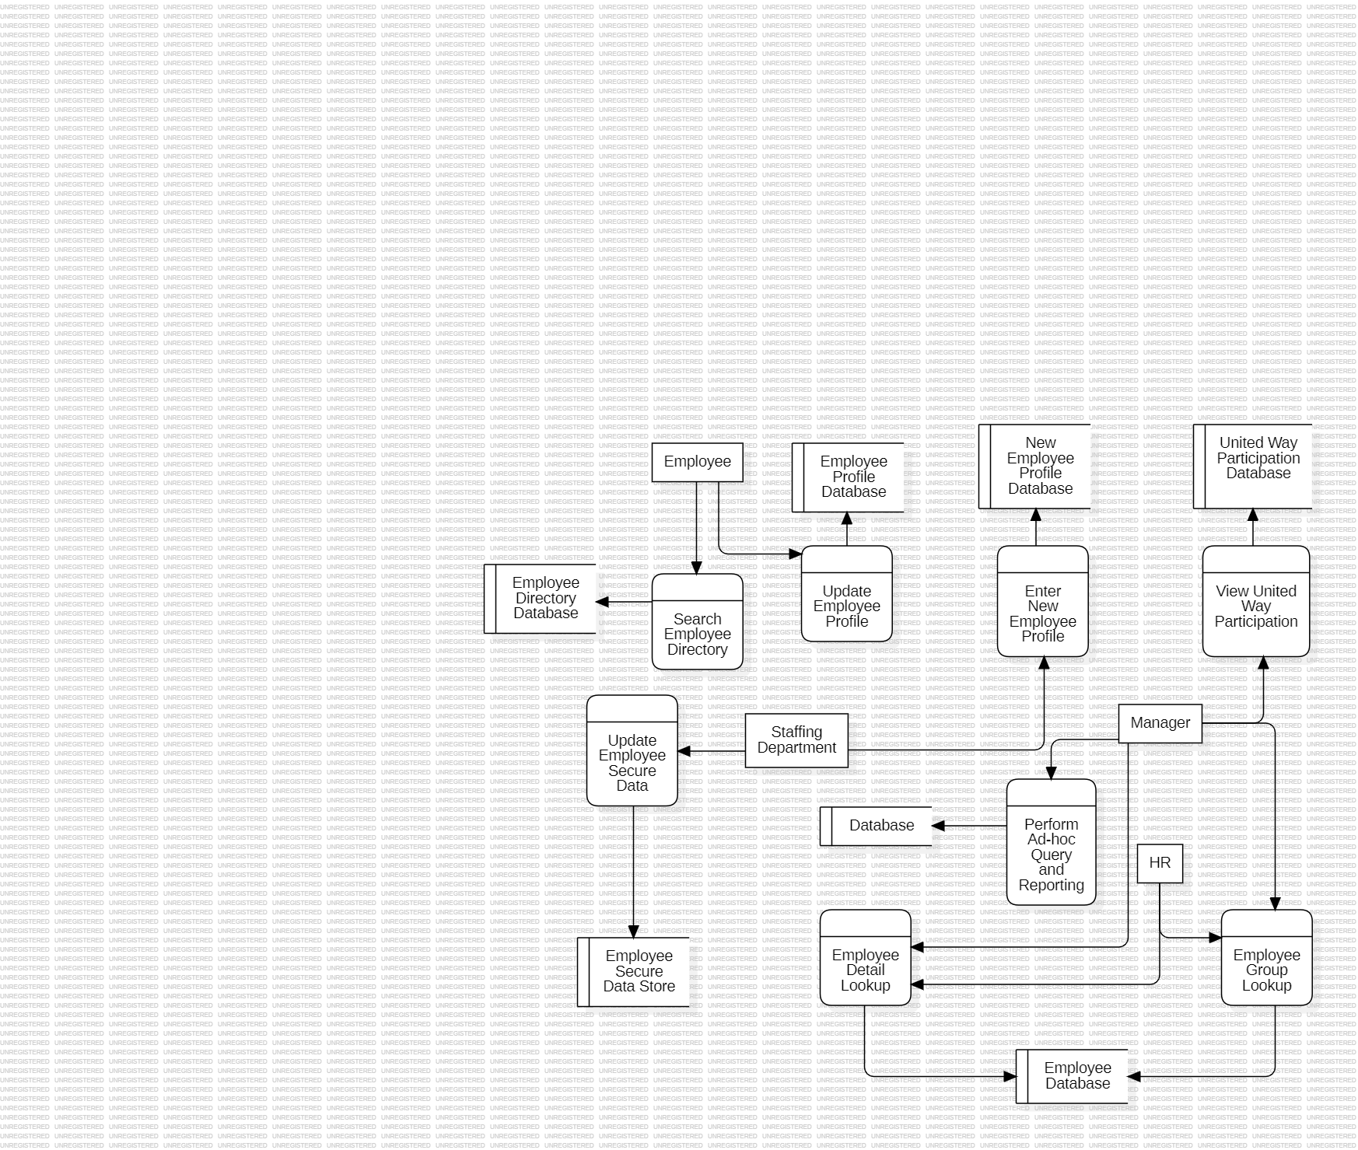

1. For all transaction processes described in the accompanying narrative, draw the *Primitive Data Flow Diagram*.

